SIMPLE EXAMPLE APPLICATIONS FOR THE UNDERSTANDING OF EVENTS FUNCTION BLOCKS

Now that we know the functionalities of almost all the events blocks, here are simple example applications using these fuction blocks.These applications may or may not have any real life applications as such, but will help in a deeper understanding of the blocks.

- PROBLEM STATEMENT: We have to build an application consisting of a counter that counts from 0 to 100 and again from 100 to 0. The time gap between each count must be 1s. There must be a provision to stop the counter at any point of time.

SOLUTION:

FUNCTION BLOCKS TO BE USED:

- E_CTUD
- E_SWITCH
- E_CYCLE
- E_PERMIT
- E_RS

STEPS TO BUILD THE APPLICATION:

- A counter can count only when its CU or CD is triggered. Since the time gap between each count must be 1s, so the CU or CD must be triggered every 1s. This can be done using a E_CYCLE FB by setting the DT at t#1s.
- Then there must be a E_SWITCH to control the triggereing of CU and CD events because after CV reaches 100 CD must be triggered and when it reaches 0 again CU must be triggered.EO of E_CYCLE must trigger E_SWITCH.
- We require a E_CTUD that is an up down counter. EO0 must trigger CU and EO1 must trigger CD.
- There are two E_PERMITS who shall be triggerd with CO. Their boolean inputs PERMIT must go from QU and QD respectively.
- EO of the E_PERMITS shall be connected to R & S of the E_RS block respectively. The boolean output Q of RS block must be given to G of E_SWITCH.
- When CV=0, QD=1, EO of E_PERMIT_0 gets triggered which in turn triggers the R and G=0, this triggers the EO0 and Counter counts up.
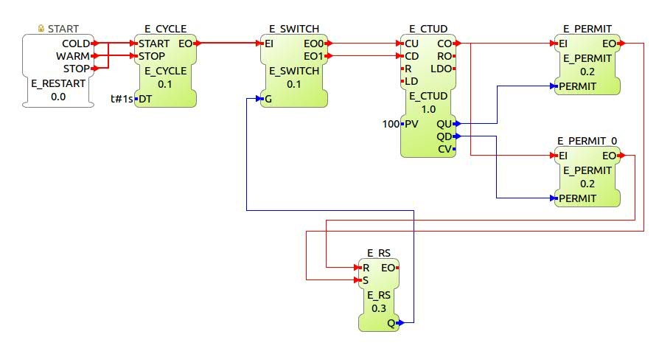
- When CV=1, QU=1, EO of E_PERMIT gets triggered which in turn triggers the S and G=1, this triggers the EO1 and Counter counts down.

This application can be mapped to a resource and deployed. It can be tested in the Debug perspective by monitoring the system and adding watch in the E_CTUD function block. The application is enclosed in this folder with name Example_App_1.
It can be imported into your workspace.
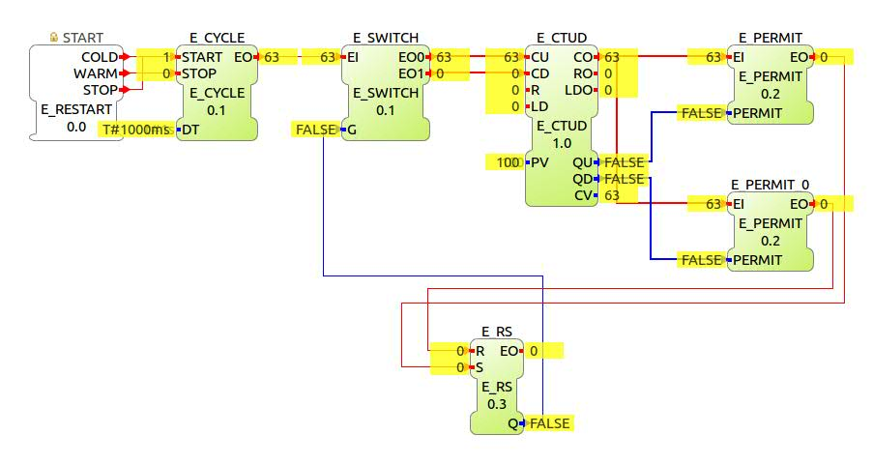
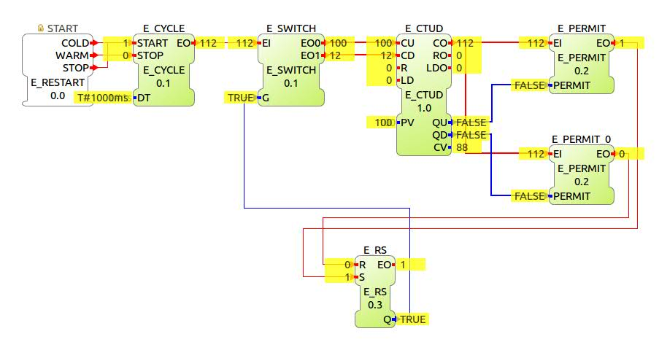

2. PROBLEM STATEMENT: We have to build the same counter as before but with a modification that the counter once reaches 50, must wait for 5s before starting to count down and once it reaches 0 , must wait for 5s before starting to count up. A red LED must turn on when CV=50 and a green LED must switch on when CV=0.

SOLUTION:

FUNCTION BLOCKS TO BE USED:

- E_CTUD
- E_SWITCH
- E_CYCLE
- E_PERMIT
- E_RS
- E_DELAY
- QX BLOCK

STEPS TO BUILD THE APPLICATION:

- A counter can count only when its CU or CD is triggered. Since the time gap between each count must be 1s, so the CU or CD must be triggered every 1s. This can be done using a E_CYCLE FB by setting the DT at t#1s.
- Then there must be a E_SWITCH to control the triggereing of CU and CD events because after CV reaches 100 CD must be triggered and when it reaches 0 again CU must be triggered.EO of E_CYCLE must trigger E_SWITCH.
- We require a E_CTUD that is an up down counter. EO0 must trigger CU and EO1 must trigger CD.
- There are two E_PERMITS who shall be triggerd with CO. Their boolean inputs PERMIT must go from QU and QD respectively.
- EO of the E_PERMITS shall be connected to LD & R of the E_CTUD block respectively. RO and LDO connected to two E_DELAYS.
- Output events of E_DELAY blocks conneced to R and S of E_RS block.The boolean output Q of RS block must be given to G of E_SWITCH.
- When CV=0, QD=1, EO of E_PERMIT_0 gets triggered which in turn triggers the R of CTUD, RO gets triggered and ges delayed by 5s before triggering the R of RS block and G=0, this triggers the EO0 and Counter counts up.
- When CV=1, QU=1, EO of E_PERMIT gets triggered which in turn triggers the LD of CTUD, LDO gets triggered and gets delayed by 5s before triggering S of RS block and G=1, this triggers the EO1 and Counter counts down.
- Finally to operate the LEDs, two QX blocks are connected with EI being triggered by CO, QI=1, PARAMS given in accordance with the resource and OUT connected to QU and QD of CTUD respectively.

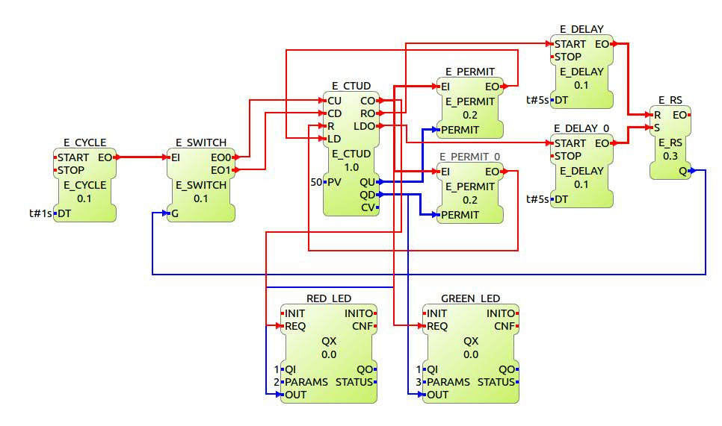
This application can be deployed to a resource and LEDs can be connected to the given parameters and tested. This application is enclosed in the folder under name example_app_2. This can be imported into your workspace. Resource used for this application is raspberry pi. You can use any other resource of your choice.

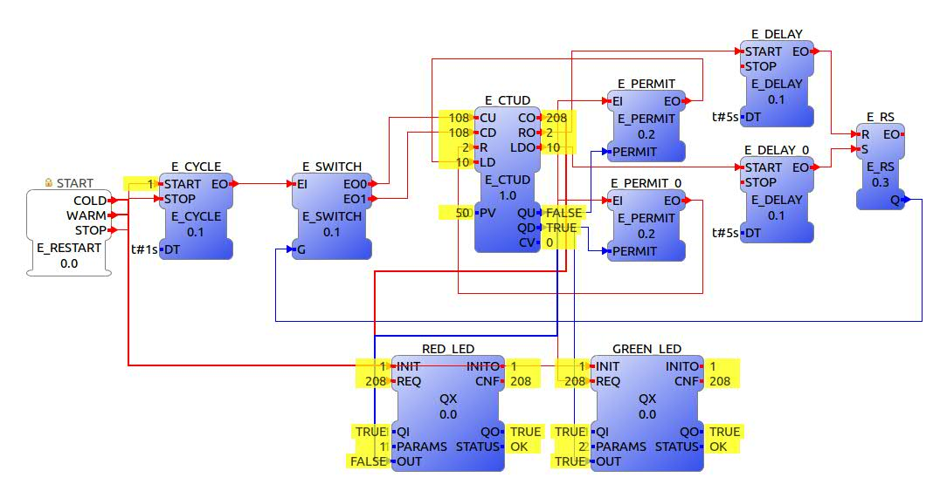

3. PROBLEM STATEMENT: To build an application to glow an LED with quarter of its full intensity i.e to glow an dimmed LED. In order to compare the Intensity there must be a LED glowing with its full intensity as well.

Solution:
To glow an dimmed LED we must make use of PWM concept. We have to produce a rectangular wave with 25% duty cycle and pass it through the LED with frequency so high that the human eye is not able to distinguish between its ON and OFF state. In this way it seems to the Human eye that the LED is continuously ON with only 25% of its full intensity.
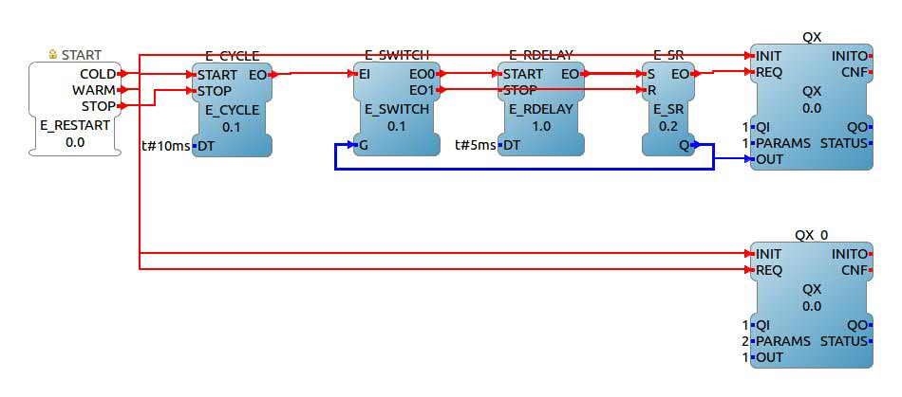
Function blocks used:
- E_CYCLE
- E_SR
- E_SWITCH
- E_DELAY
- QX block

STEPS FOR BUILDING THE APPLICATION.:
- In order to form the square wave of 25% duty cycle, E_CYCLE is connected to a E_SWITCH. EO0 triggers the E_DELAY and EO1 triggers R of E_SR. EO of E_DELAY triggers S of E_SR and Q of E_SR is feeded back to G of E_SWITCH.
- For making the frequency high, DT of E_CYCLE is chosen to be 10ms.
- For making it 25% duty cycle, DT of E_DELAY is made half of that of E_CYCLE i.e 5ms.
- When Q=1; G=1; EO1 is selected; R is triggered and Q becomes 0. Similarly now Q=0; G=0; EO0 is selected; it is delayed for 5ms before triggering S and Q becomes 1.
- The Q is connected to the QX block and proper PARAMETERS are given in accordance with the selected resource pins. (Resource selected here is a Raspberry pi)
- For comparision purpose another QX block is connected directly to the RESTART block of emb.resource. Its QI=1; PARAMS: according to your selected resource and IN=1.

This application is enclosed in the folder under the name Example_App_3. This can be imported into your workspace.

4. PROBLEM STATEMENT: Build an application to continuously glow an LED from its highest intensity to lowest intensity. In other words produce PWM signals with different duty cycles and pass it through an LED to observe the change in intensity.

SOLUTION:
The fundamental concept remains same as that of the previous example but in this example we will first produce a square wave signal of a particular frequency and then change its ON and OFF times. For doing so, we first build a BLINK LED application with DT as 5ms. This will produce square wave signal of time period 10ms.
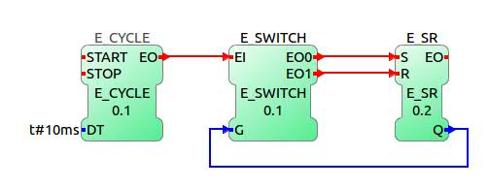
Now the output Q of the blink LED app is sent to E_R_TRIG block. This block produces an output event when there is a transition in QI from 0 to 1. This event now triggers E_RDELAY.DT of E_RDELAY is actually responsible to change the duty cycle of the wave. EO of this block triggers the S of E_SR block, EO1 of E_SWITCH(LED BLINK App) triggers the R of the E_SR block. Q of this block is given to OUT of the QX block.
Now DT of R_DELAY must be increased from 0 to 10ms in order to change the duty cycle. When it is changed from 5ms to 10ms, duty cycle changes from 100% to 50%. and when it is changed from 0ms to 5ms intensity changes from 50% to 0 %.

Hence we use an up counter whose CU is triggered every 500ms using an E_CYCLE block. When the counter output reaches 10, it is reset to 0 using the E_PERMIT. The UINT output of the counter is converted into time in seconds and is then divided by 1000 to get time in miliseconds. Then the output is given to DT of E_R_DELAY.
This application is then deployed to Raspberry pi EMB.RES with the LED attached to the pin specified in the PARAMS of the QX block.

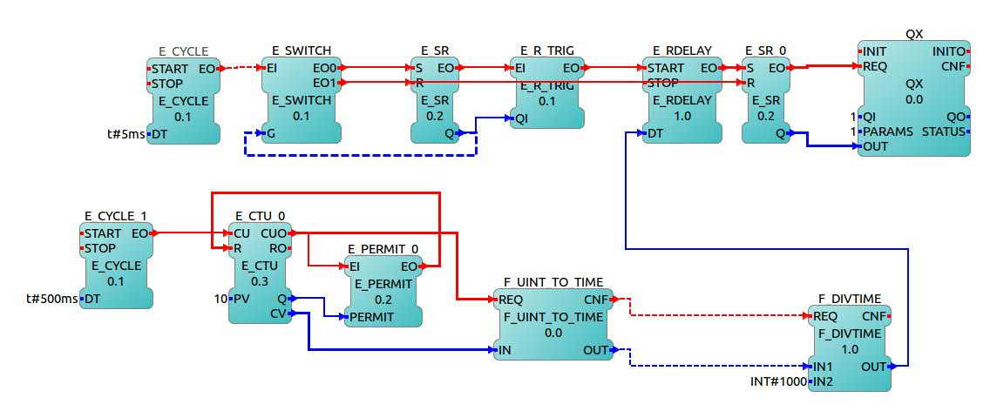

This application is enclosed in the folder with name LED_DIM_EXAMPLE. It can be imported into your workspace.

